1. **Code_1**  
   **Input:** No input  
   **Output:**

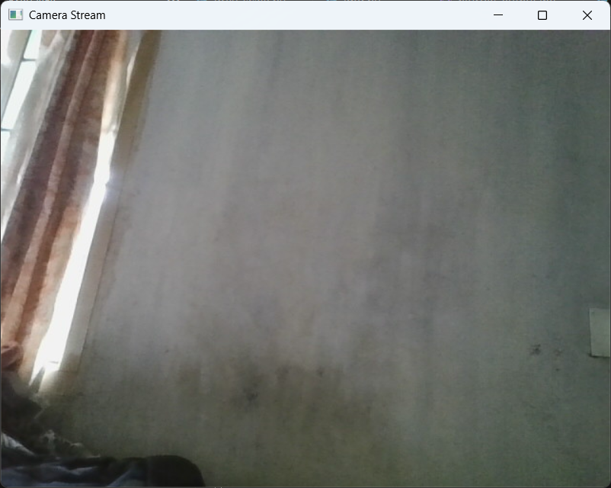  
**Logic:** It displays a live video feed in a window titled Camera Stream. Each frame captured by the webcam is shown continuously until the user presses ‘q’, after which the camera is released and the window closes.

1. **Code_2**  
   **Input:** No input  
   **Output:**

  
**Logic:** Displays a live video feed in a window titled Camera Stream. Simultaneously, each captured frame is saved automatically as an image inside a folder named frames with sequential filenames like frame_000000.jpg, frame_000001.jpg, etc. On pressing ‘q’, the video stops, and the window closes, releasing the camera.

1. **Code_3**  
   **Input:**

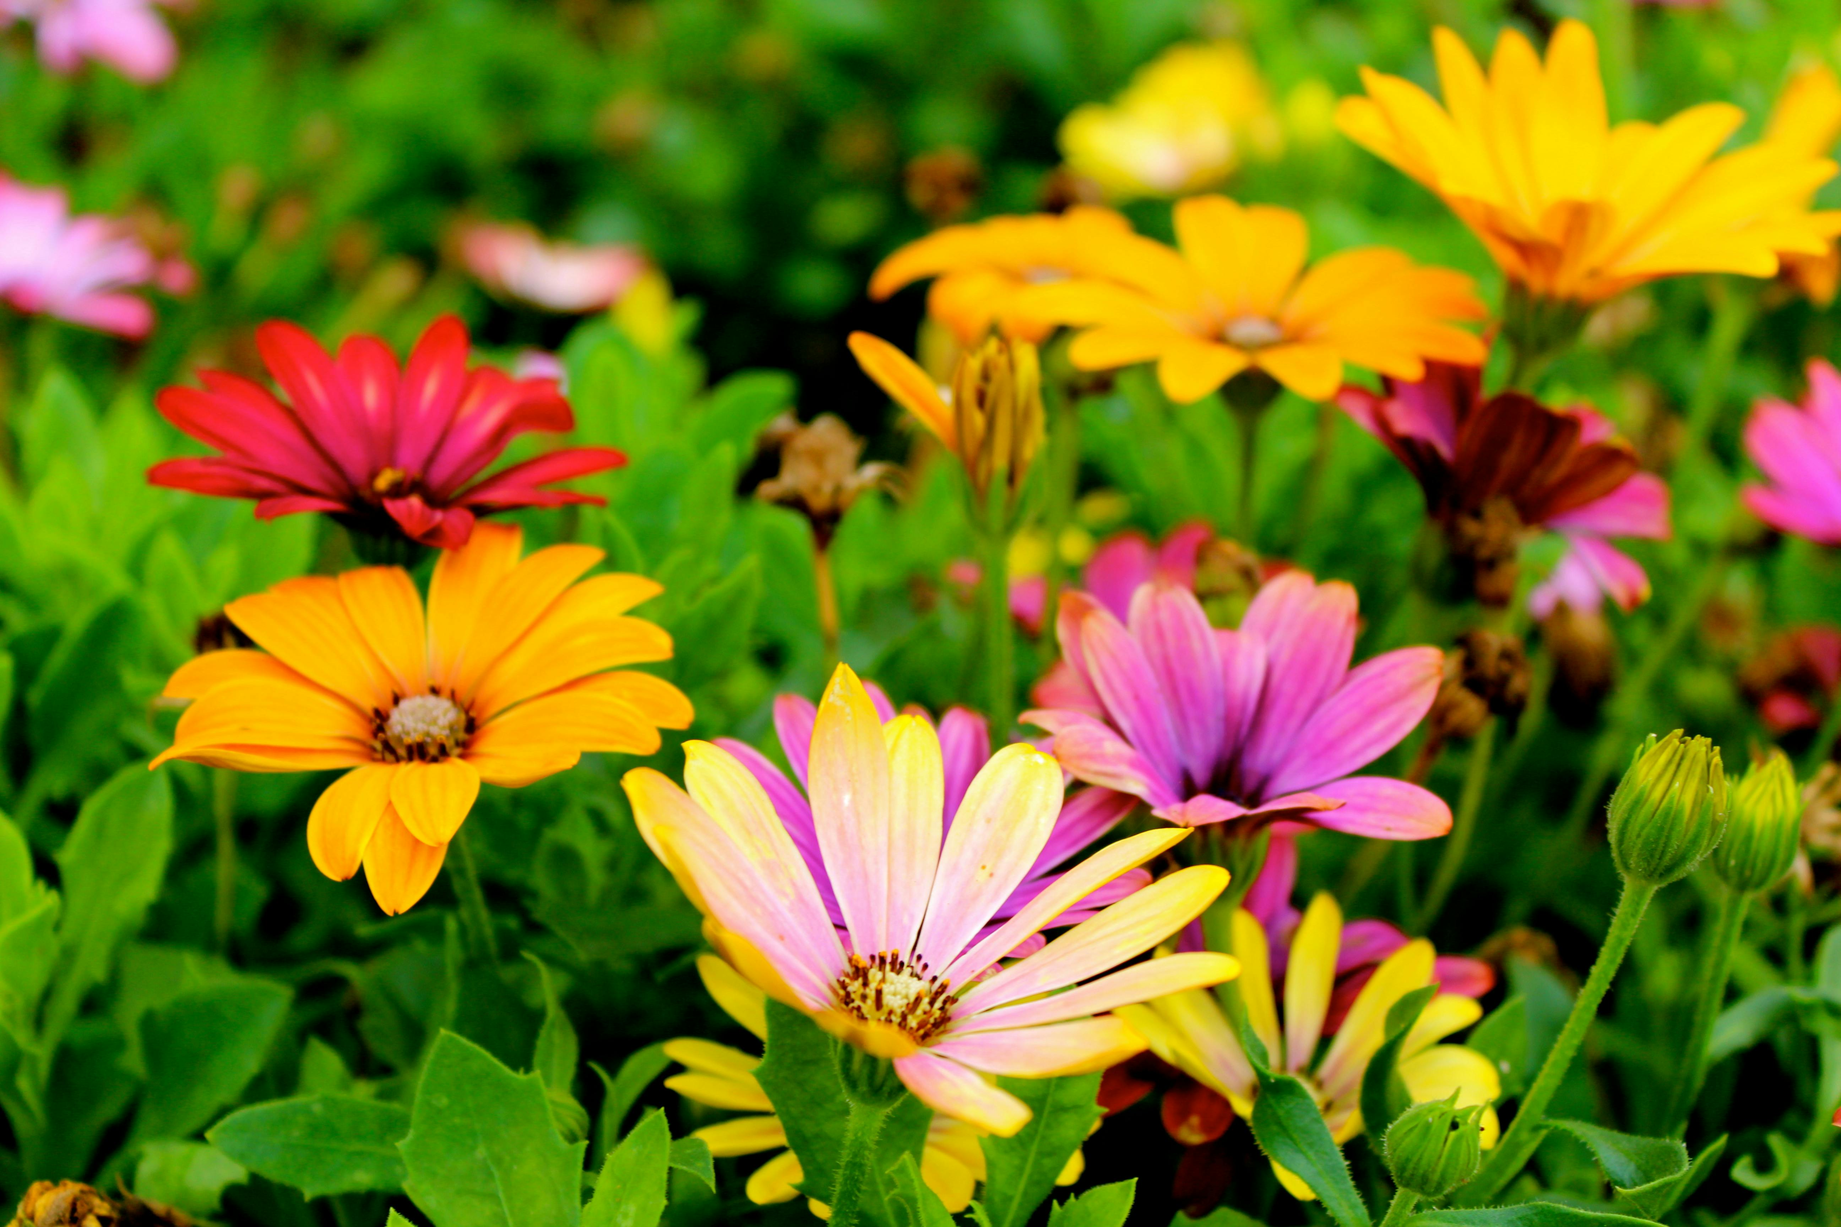  
**Output:**

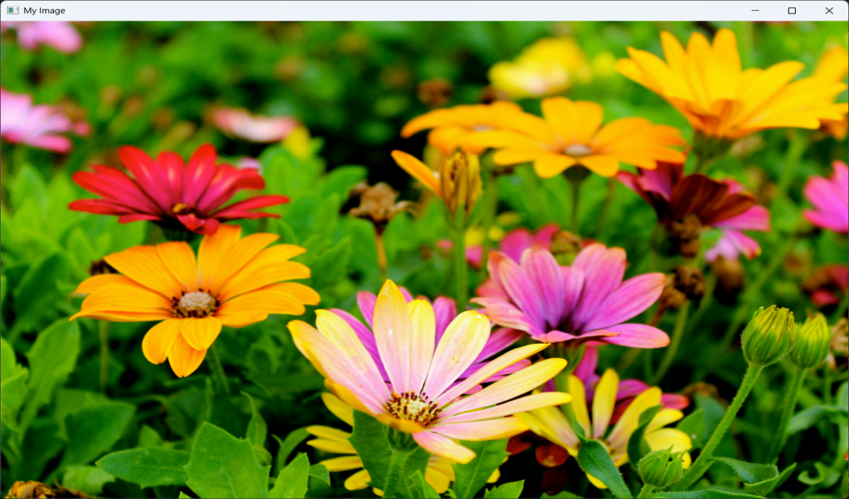  
**Logic:** If the image is successfully loaded, it is displayed in a window titled My Image. If the image path is incorrect or the file is missing, it displays an error message: “Error: Could not read image.”

1. **Code_4**

**Input:**  
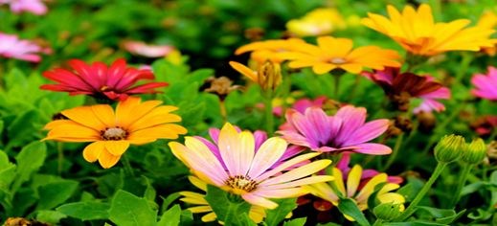

**Output:**

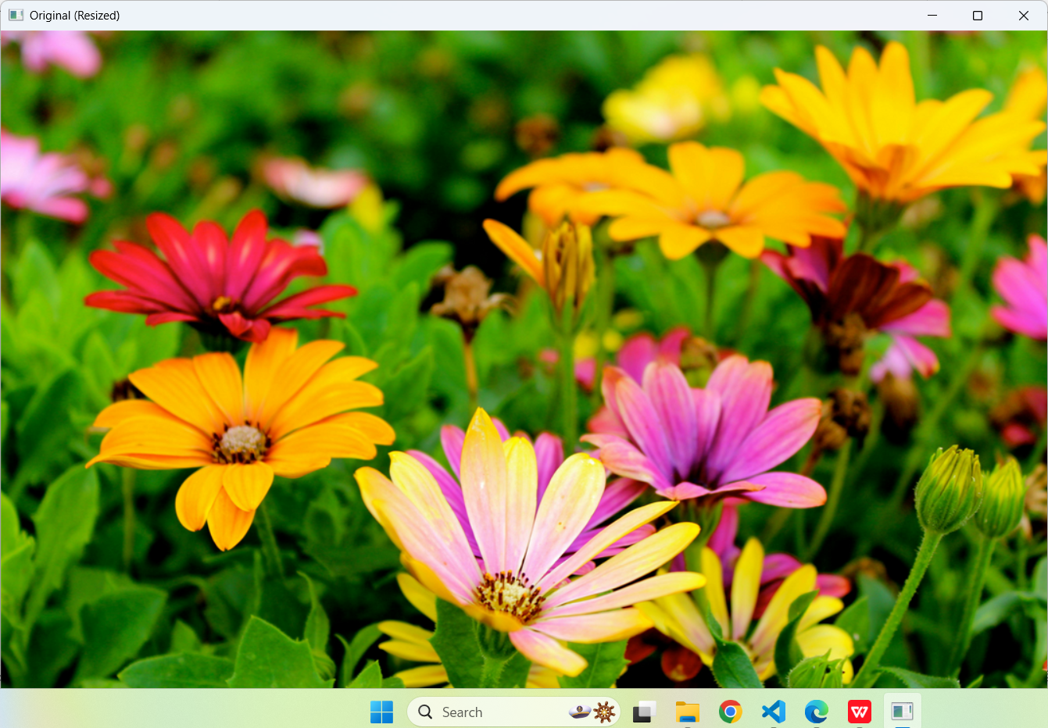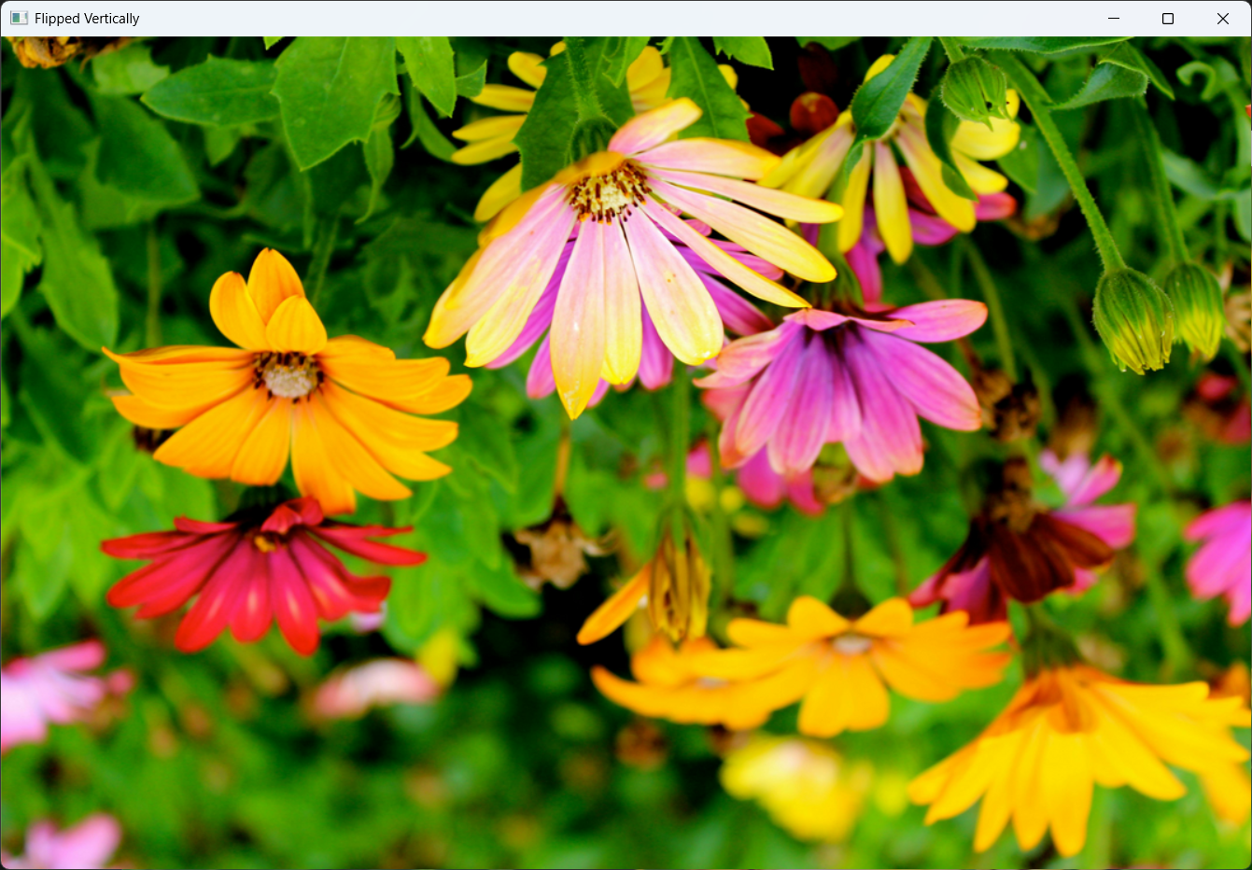  
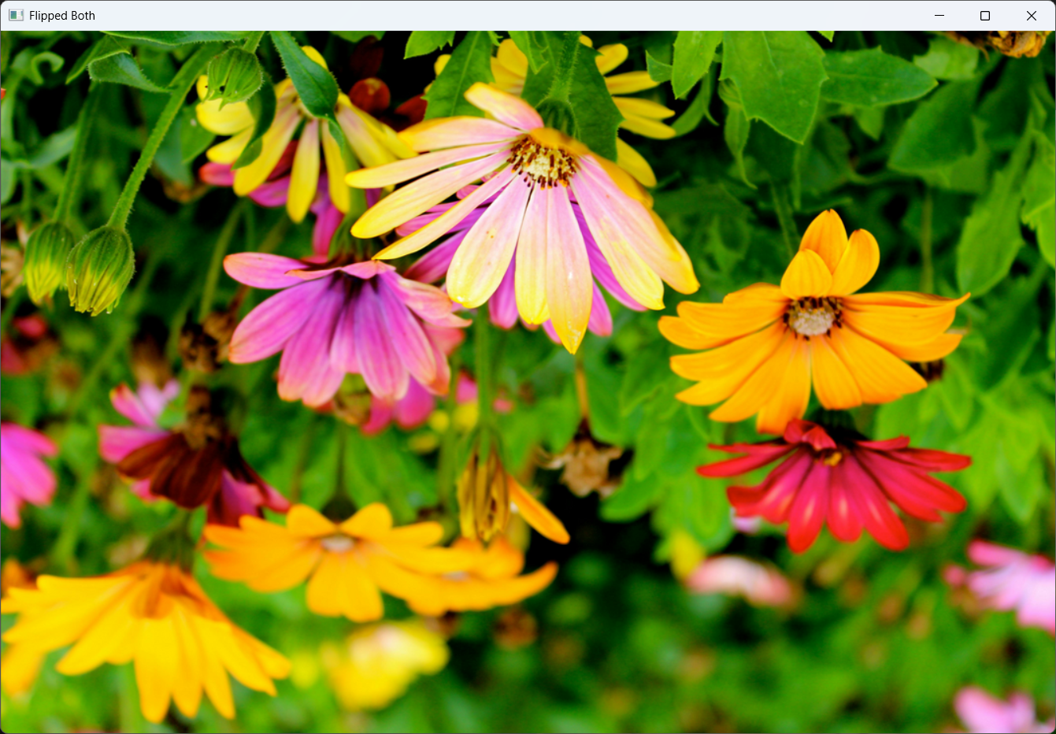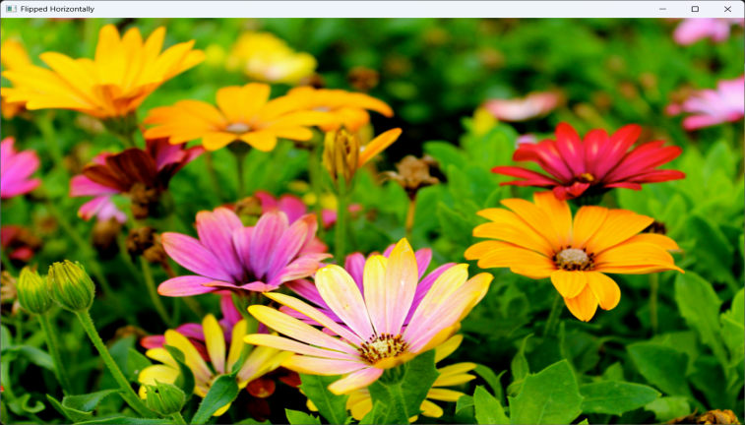

**Logic:** The program reads the input image and creates three flipped versions: vertically, horizontally, and both. It displays four windows showing the original image, vertically flipped image, horizontally flipped image, and image flipped both ways. If the image cannot be loaded, it prints "Error: Could not read image."

1. **Code_5**

**Input:**  


**Output:**

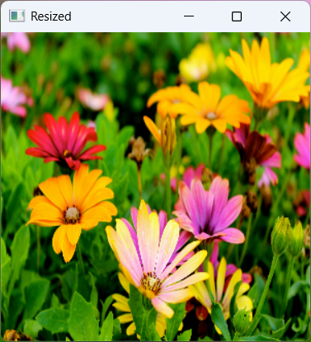  
**Logic:** The program displays two windows, one showing the original image and another showing the resized image with dimensions 300x300 pixels. After any key is pressed, both windows close, and the resized image is saved in the current working directory as resized_output.jpg. If the image cannot be loaded, it prints the message "Error: Could not read image."

1. **Code_6**  
   **Input:**



**Output:**

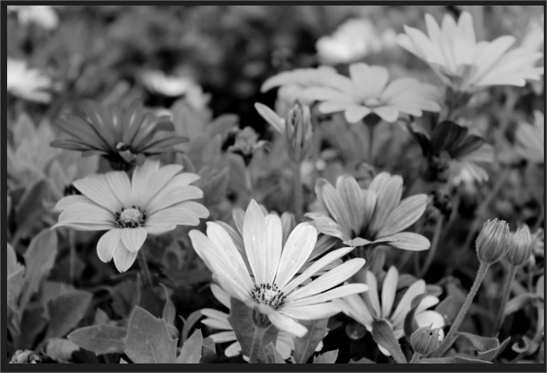  
**Logic:** The program reads the input image, converts it to a grayscale version using OpenCV’s color conversion function, and displays both the original and grayscale images in separate windows. On pressing any key, the windows close, and the grayscale image is saved as grayscale_output.jpg. If the image fails to load, it prints "Error: Could not read image.

1. **Code_7**  
   **Input:**

  
**Output:**

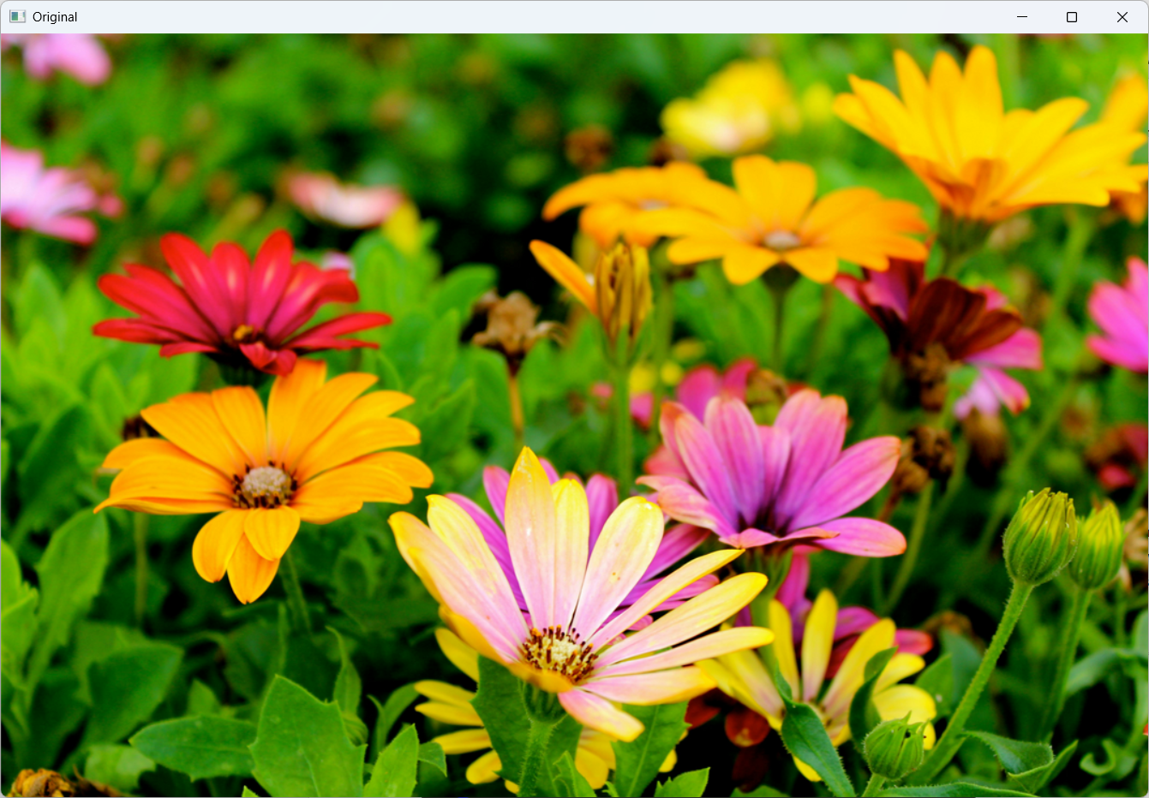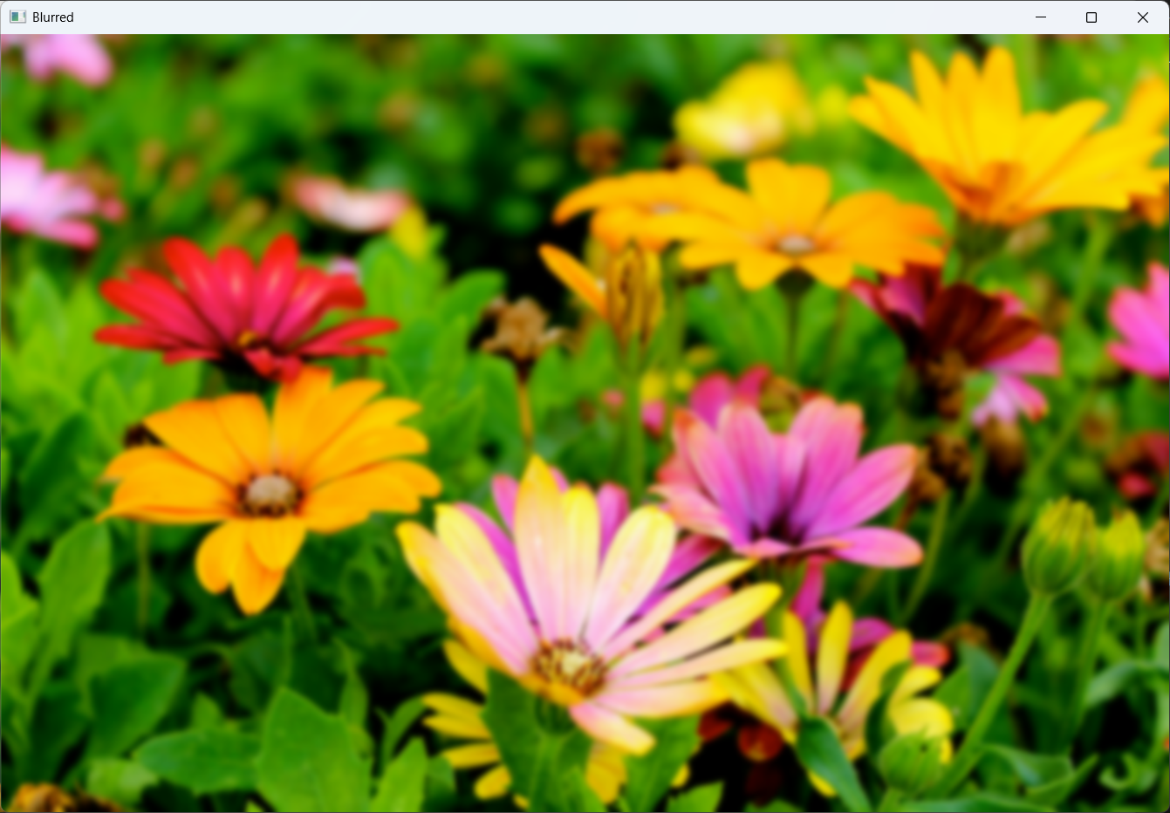

**Logic:** The program reads the input image and applies a Gaussian Blur with a 15x15 kernel to reduce noise and smooth the image. It displays both the original and blurred images in separate windows. On pressing any key, the windows close, and the blurred image is saved as blurred_output.jpg. If the image cannot be loaded, it prints "Error: Could not read image."

1. **Code_8**  
   **Input:** No input (an empty black image is created using NumPy).  
   **Output:**

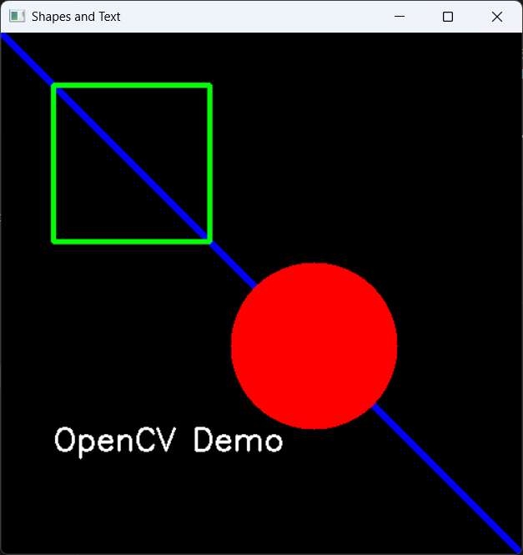  
**Logic:** The program creates a blank 500x500 black image and draws a blue diagonal line, a green rectangle, and a filled red circle on it. It also adds the text "OpenCV Demo" in white color at the bottom. The final image with shapes and text is displayed in a window titled "Shapes and Text" until a key is pressed.

1. **Code_9**

**Input:**  


**Output:**

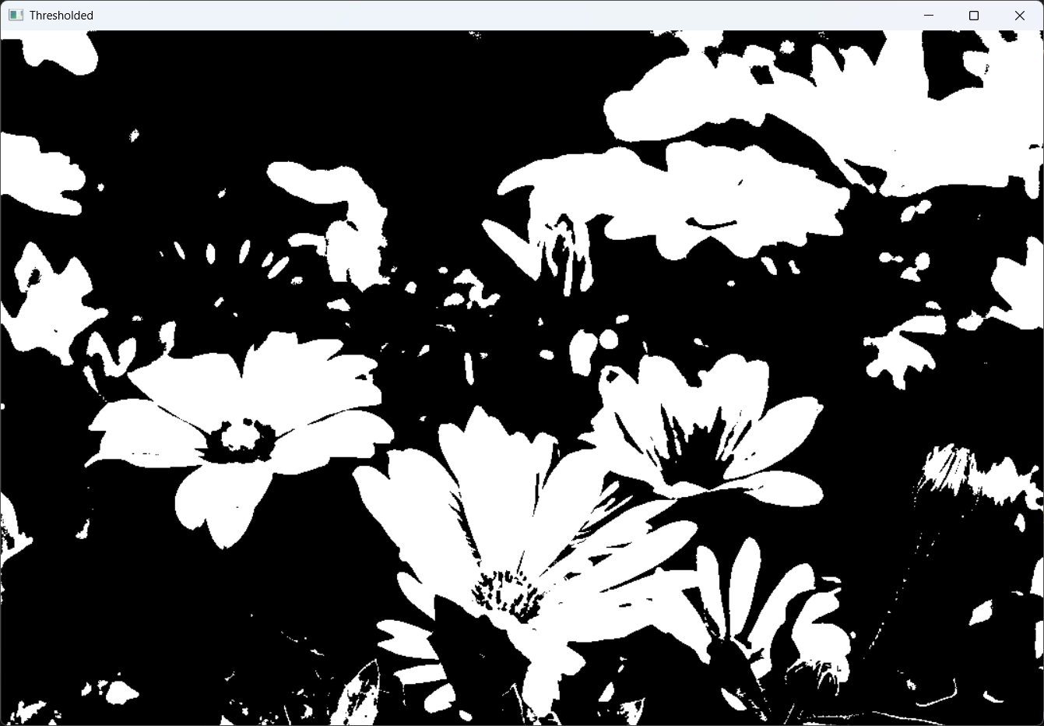  
**Logic:** The program loads the image in grayscale mode and applies a binary threshold with a threshold value of 127. Pixels with intensity above 127 are set to 255 (white), and those below are set to 0 (black). It displays both the original and thresholded images in separate windows until a key is pressed.

1. **Code_10**  
   **Input:**

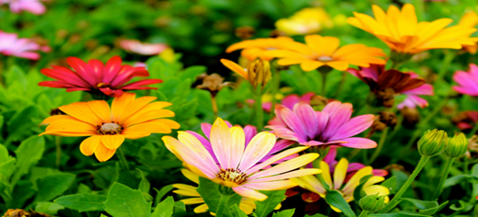  
**Output:**

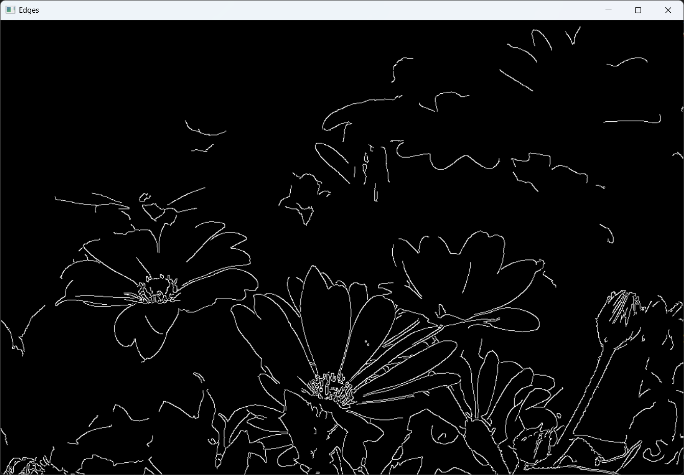  
**Logic:** The program reads the image in grayscale mode and applies the Canny edge detection algorithm with threshold values 100 and 200 to detect edges in the image. The resulting edge-detected image is displayed in a window titled "Edges" until a key is pressed.

1. **Code_11**  
   **Input:**

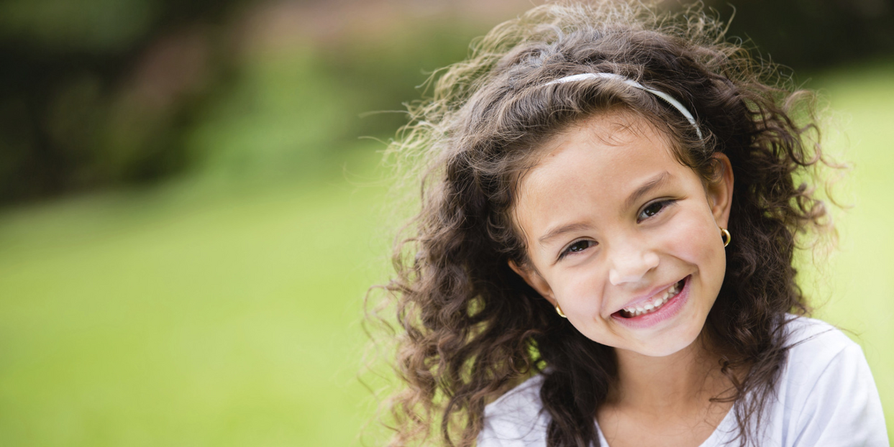  
**Output:**

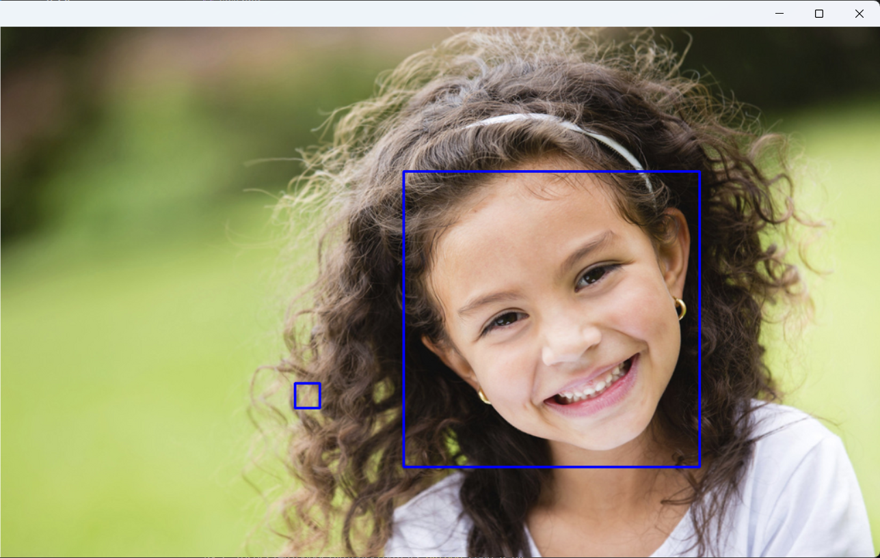  
**Logic:** The program uses a pre-trained Haar Cascade Classifier for face detection. It converts the input image to grayscale, detects faces using the classifier, and draws blue rectangles around detected faces. The processed image with highlighted faces is displayed in a window titled "Face Detection" until a key is pressed.

1. **Code_12**

**Input:**  
  
**Output:**  
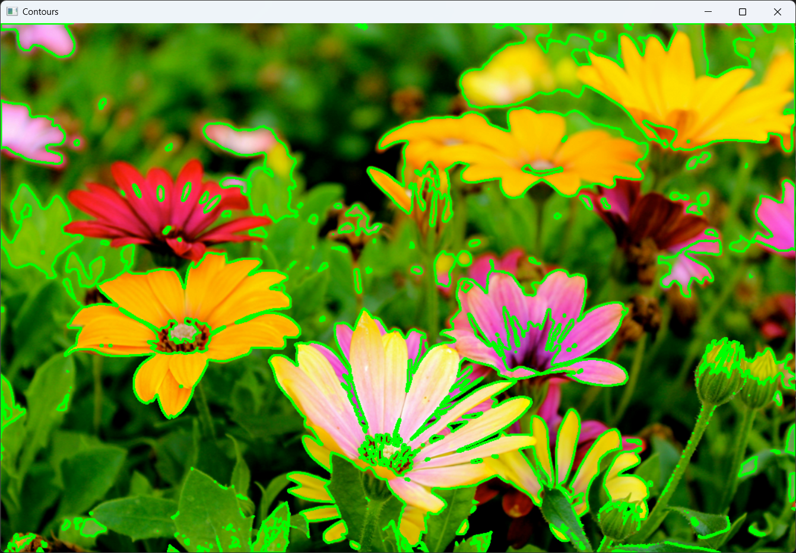

**Logic:** The program reads an image, converts it to grayscale, and applies binary thresholding. It then detects contours in the image and outlines them using green lines with a thickness of 2 pixels. The final image showing all detected contours is displayed in a window titled "Contours" until a key is pressed.

1. **Code_13**  
   **Input:**

  
**Output:**



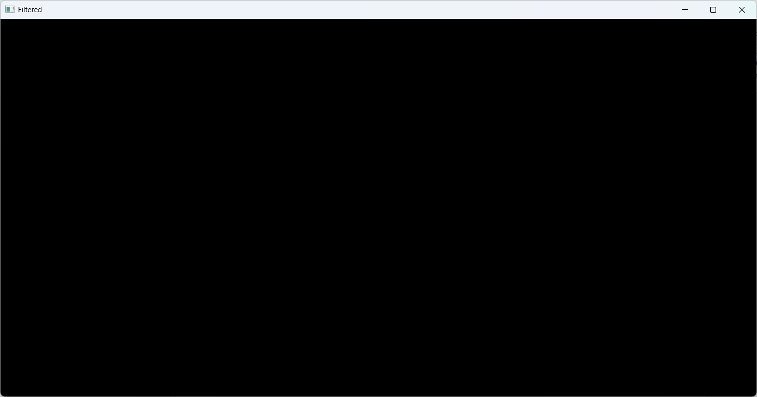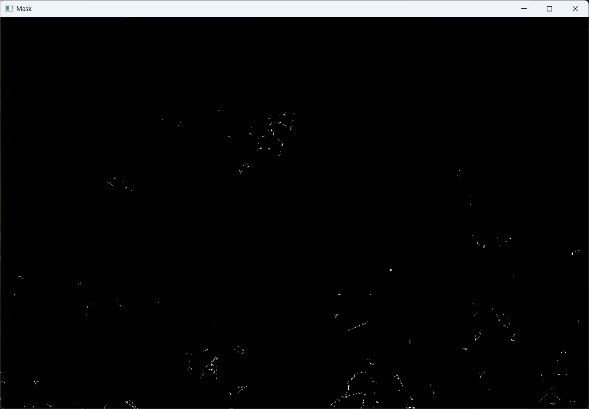

**Logic:** The program reads the input image and converts it to HSV color space. It defines a blue color range and creates a mask to isolate blue regions. Using bitwise AND, it filters the original image to show only the blue areas. Three windows display the original image, the mask, and the filtered result until a key is pressed.

1. **Code_14**  
   **Input:**

  
**Output:**

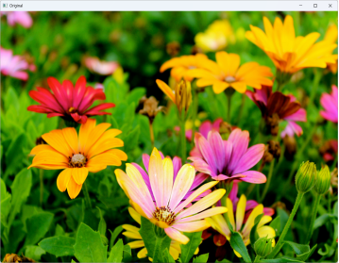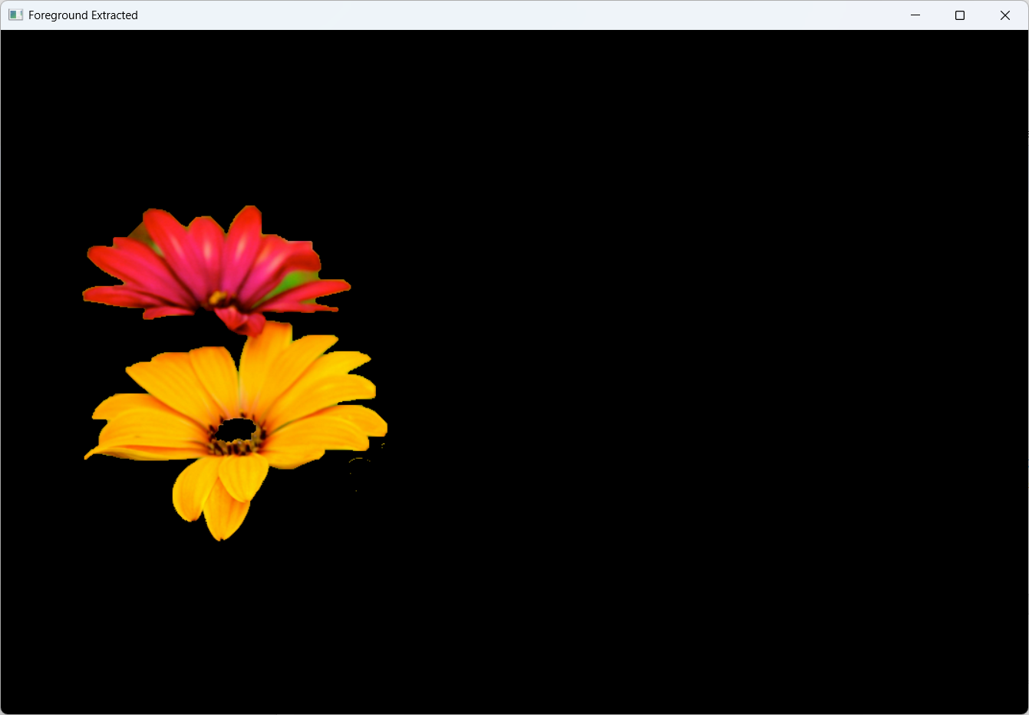  
**Logic:** The program performs foreground extraction using the GrabCut algorithm. It defines a rectangular region of interest (ROI) and separates the foreground from the background by iteratively refining pixel classifications. The result displays only the extracted foreground from the original image in a window titled "Foreground Extracted."

1. **Code_15**

**Input:**

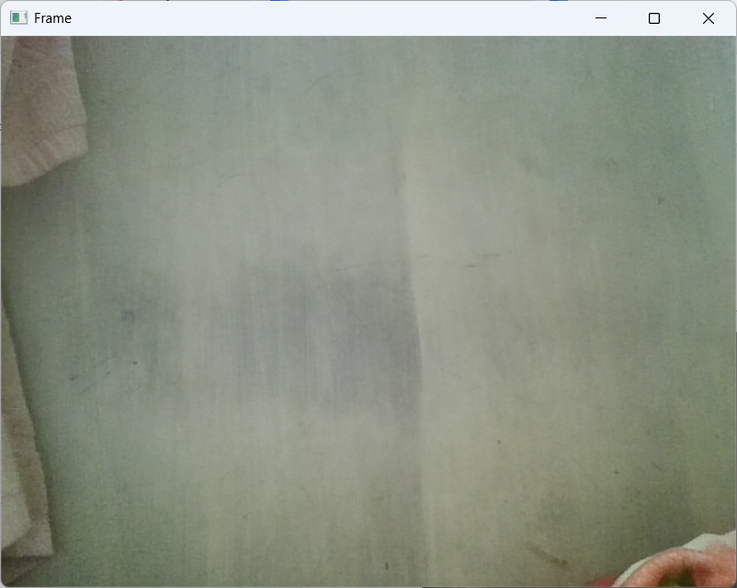  
**Output:**

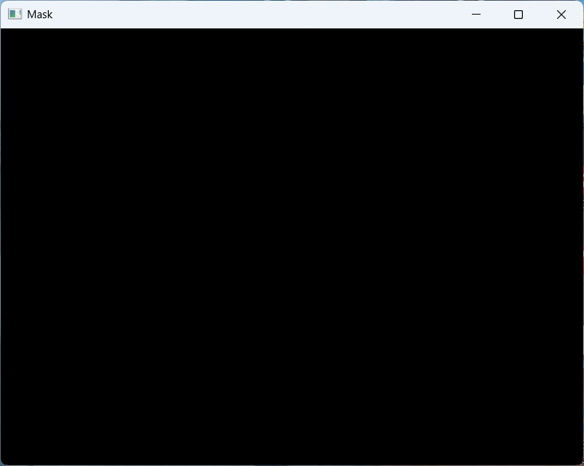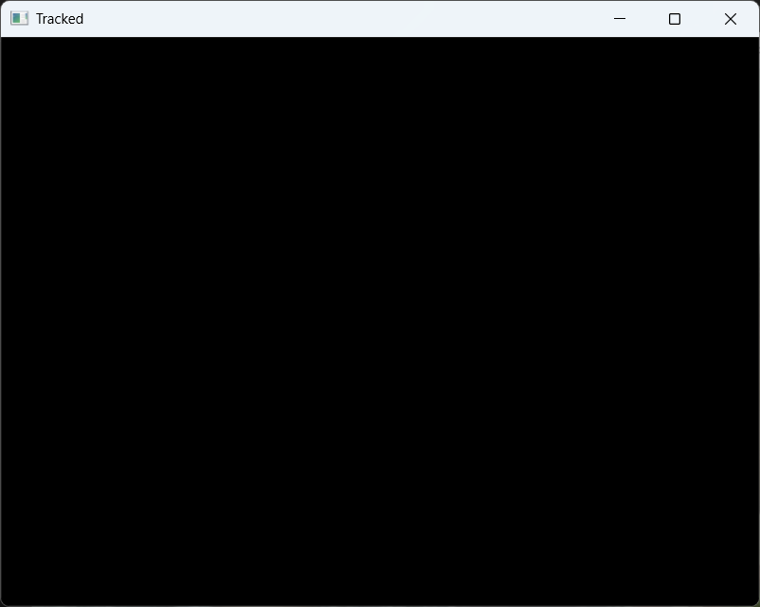  
**Logic:** The program captures video frames from the webcam, converts each frame into HSV color space, and applies a color mask to detect blue regions. It displays the original frame, the mask, and the tracked blue-colored output in real time. The process continues until the user presses ‘q’, after which the camera is released.

1. **Code_16**  
   **Input:**

  
**Output:**

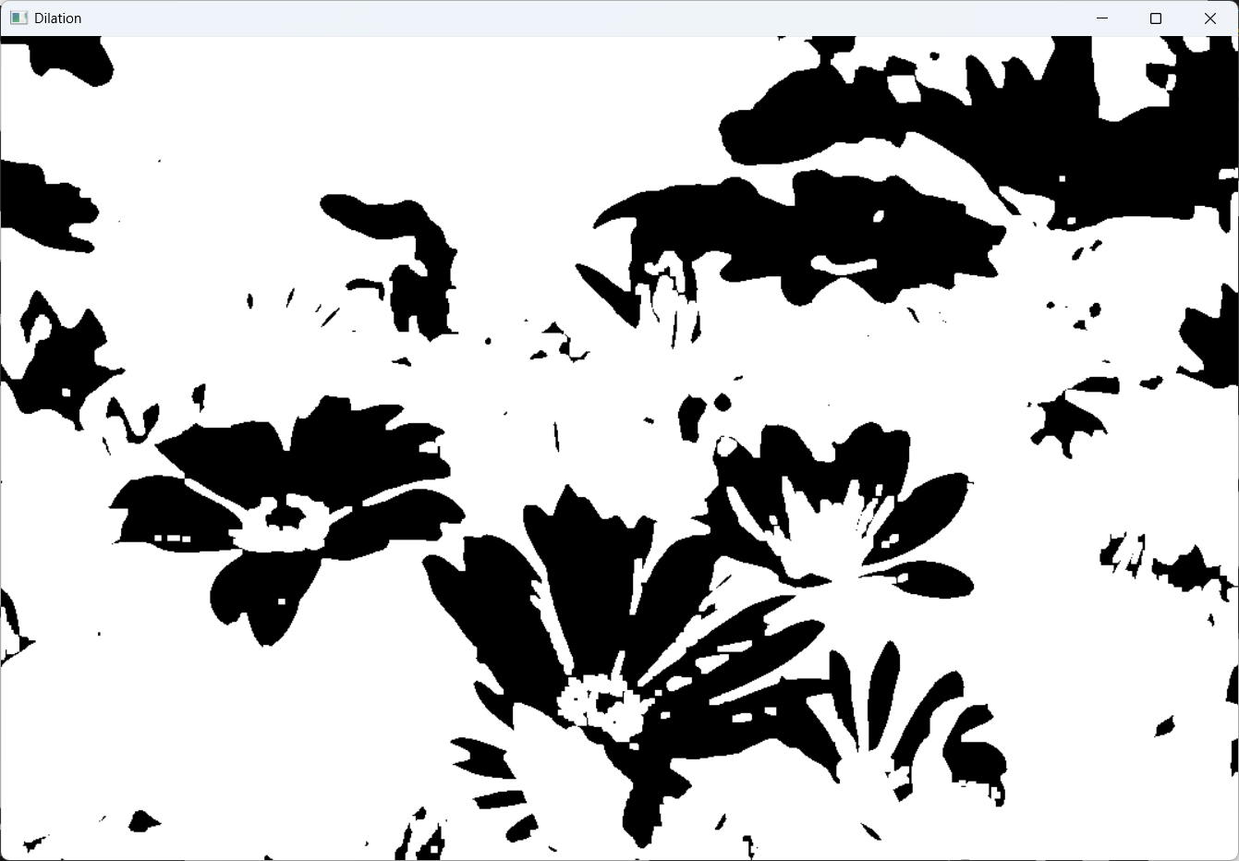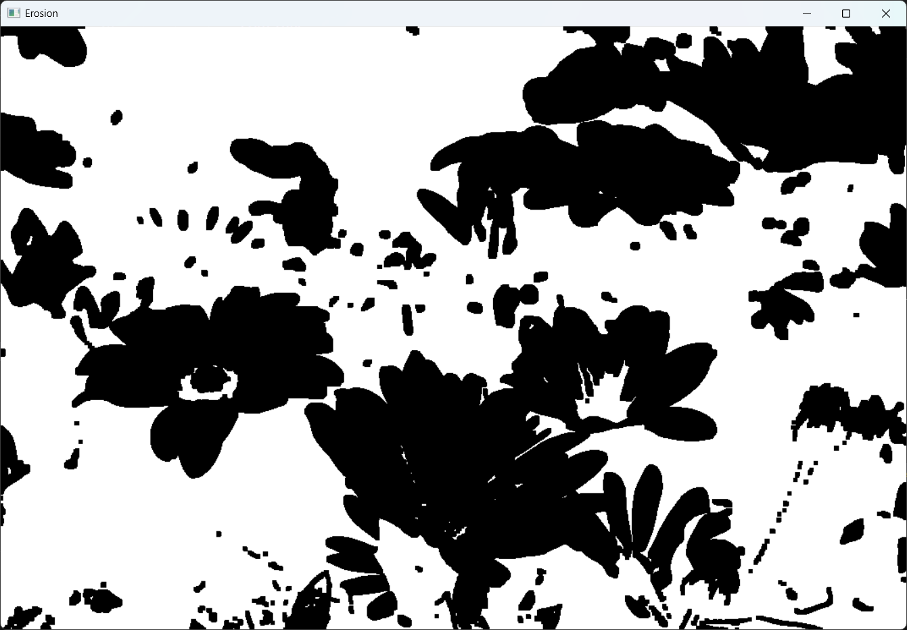

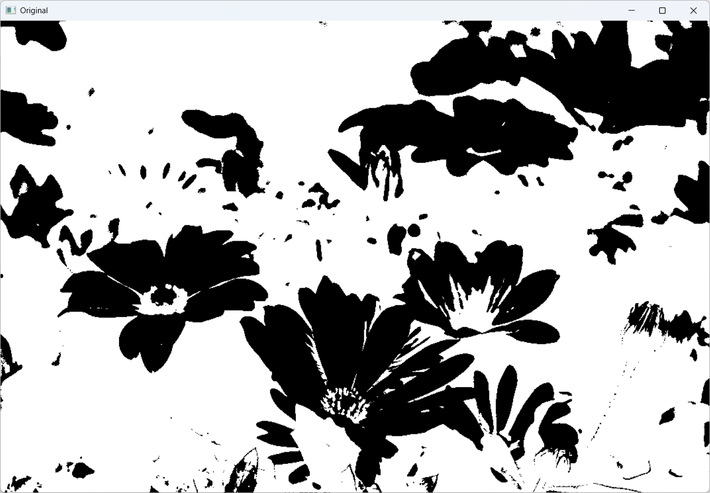  
**Logic:** The program converts the image to grayscale, applies inverse binary thresholding, and then performs morphological operations. Erosion reduces white regions by shrinking them, while dilation expands white regions. Three windows display the thresholded image, the eroded image, and the dilated image until a key is pressed.

1. **Code_17**  
   **Input:** Emails like help@site.com are filtered. I’m LOVING NLP!!! Visit https://x.y.  
   **Output:** **['email', 'like', 'filter', 'love', 'nlp', 'visit']**  
   **Logic:** The program cleans the input text by converting it to lowercase, removing URLs, emails, hashtags, mentions, and unwanted characters. It then tokenizes the cleaned text using spaCy, removes stopwords, removes very short tokens, and converts words to their lemmas. The final output is a list of processed, meaningful tokens.
2. **Code_18**  
   **Input:**

[

"I loved this movie, fantastic acting and great story",

"This film was terrible and boring",

"Absolutely wonderful experience, highly recommend",

"Worst acting ever, do not watch",

"It was okay, some parts were fun",

"I hated the plot, very disappointing",

"Brilliant direction and superb cast",

"Not good, waste of time",

"Enjoyable and engaging from start to finish",

"Awful soundtrack and weak story"

]  
**Output:**

Classification report:

precision recall f1-score support

0 0.0000 0.0000 0.0000 2

1 0.3333 1.0000 0.5000 1

accuracy 0.3333 3

macro avg 0.1667 0.5000 0.2500 3

weighted avg 0.1111 0.3333 0.1667 3

Confusion matrix:

[[0 2]

[0 1]]

Predictions: [1 1]

Class probabilities: [[0.42652933 0.57347067]

[0.46719711 0.53280289]]  
**Logic:T** he program splits the dataset into training and testing sets, then builds a TF-IDF + Logistic Regression pipeline for sentiment classification. After training, it prints the classification report and confusion matrix for the test set. Finally, it predicts the sentiment and class probabilities for two sample input sentences, showing how the model classifies new text.

1. **Code_19**  
   **Input:**

[

"excellent movie with great acting",

"terrible plot and awful pacing",

"loved every moment, fantastic!",

"boring and predictable",

"superb cinematography and direction",

"weak script and bad acting",

"what a masterpiece",

"not good at all",

"brilliant experience overall",

"do not recommend"

]  
**Output:**

Best params: {'clf__C': 4.0, 'tfidf__analyzer': 'char_wb', 'tfidf__min_df': 1, 'tfidf__ngram_range': (1, 2)}

Best CV score (f1): 0.7222222222222222

Sample prediction: [1]  
**Logic:** The code creates a text-classification pipeline and uses GridSearchCV to test different TF-IDF and Logistic Regression settings. It performs 3-fold cross-validation to find the best-performing parameter combination. Finally, it outputs the best parameters, best F1 score, and a sample prediction using the optimized model.

1. **Code_20**  
   **Input:**

[ "machine learning is fun", "deep learning advances machine intelligence", "artificial intelligence and machine learning" ]  
**Output:**

Vocabulary: ['advances' 'and' 'artificial' 'deep' 'fun' 'intelligence' 'is' 'learning'

'machine']

TF-IDF Matrix:

advances and artificial deep fun intelligence is learning machine

0 0.000 0.000 0.000 0.000 0.609 0.00 0.609 0.360 0.360

1 0.552 0.000 0.000 0.552 0.000 0.42 0.000 0.326 0.326

2 0.000 0.552 0.552 0.000 0.000 0.42 0.000 0.326 0.326  
**Logic:** The code applies TfidfVectorizer to convert text documents into numerical TF-IDF features. It then transforms the result into a DataFrame for readability and prints both the extracted vocabulary and the TF-IDF matrix.

1. **Code_21**  
   **Input:**

("Apple is opening a new office in Bengaluru next quarter. "

"Tim Cook met Karnataka officials on September 3, 2025 to discuss expansion.")  
**Output:**

Named Entities (text, label):

Apple -> ORG

Bengaluru -> GPE

next quarter -> DATE

Tim Cook -> PERSON

Karnataka -> GPE

September 3, 2025 -> DATE

Part-of-Speech & Lemmas:

Apple POS=PROPN Lemma=Apple

is POS=AUX Lemma=be

opening POS=VERB Lemma=open

a POS=DET Lemma=a

new POS=ADJ Lemma=new

office POS=NOUN Lemma=office

in POS=ADP Lemma=in

Bengaluru POS=PROPN Lemma=Bengaluru

next POS=ADJ Lemma=next

quarter POS=NOUN Lemma=quarter

. POS=PUNCT Lemma=.

Tim POS=PROPN Lemma=Tim

Cook POS=PROPN Lemma=Cook

met POS=VERB Lemma=meet

Karnataka POS=PROPN Lemma=Karnataka

officials POS=NOUN Lemma=official

on POS=ADP Lemma=on

September POS=PROPN Lemma=September

3 POS=NUM Lemma=3

, POS=PUNCT Lemma=,

2025 POS=NUM Lemma=2025

to POS=PART Lemma=to

discuss POS=VERB Lemma=discuss

expansion POS=NOUN Lemma=expansion

. POS=PUNCT Lemma=.

Noun chunks (base NPs):

['Apple',

'a new office',

'Bengaluru',

'Tim Cook',

'Karnataka officials',

'September',

'expansion']  
**Logic:** The code takes the input text, processes it using **spaCy’s NLP pipeline**, and then extracts **Named Entities, POS tags with lemmas**, and **noun chunks** from the processed doc object.

1. **Code_22**  
   **Input:**

[ "I love this movie", "This film was awful", "Amazing performance and great story", "Boring and too long", "Fantastic acting", "Terrible direction" ]  
**Output:**

Classification Report:

precision recall f1-score support

0 0.50 1.00 0.67 1

1 0.00 0.00 0.00 1

accuracy 0.50 2

macro avg 0.25 0.50 0.33 2

weighted avg 0.25 0.50 0.33 2  
**Logic:** The code converts text into Bag-of-Words features, trains a **Multinomial Naive Bayes** classifier on labeled sentiment data, and then predicts sentiments for the test set to print the **classification report**.

1. **Code_23**  
   **Input:**

[ "I love machine learning and NLP", "NLP and machine learning are amazing", "Cooking recipes are fun to try", ]  
**Output:**

**Cosine Similarity Matrix:**

**[[1. 0.64424596 0. ]**

**[0.64424596 1. 0.12413287]**

**[0. 0.12413287 1. ]]**

**Logic:** The code converts documents into TF-IDF vectors, then computes cosine similarity to measure how similar each document is to every other. Finally, it prints the similarity matrix showing pairwise similarity scores.

1. **Code_24**  
   **Input:**

[ "I love deep learning and natural language processing", "Artificial intelligence is the future", "Cooking and baking are my hobbies", "I enjoy trying new recipes in the kitchen", "Machine learning and AI are closely related" ]  
**Output:**

Topic 0: 0.076*"the" + 0.046*"in" + 0.046*"enjoy" + 0.046*"trying" + 0.046*"kitchen" + 0.046*"new" + 0.046*"recipes" + 0.045*"i" + 0.045*"artificial" + 0.045*"intelligence"

Topic 1: 0.089*"and" + 0.085*"learning" + 0.052*"are" + 0.052*"i" + 0.051*"processing" + 0.051*"natural" + 0.051*"language" + 0.051*"love" + 0.051*"deep" + 0.051*"related"  
**Logic:** The code tokenizes documents, builds a dictionary–corpus, trains an LDA topic model, and prints the discovered topics.